EXPERIENCIA

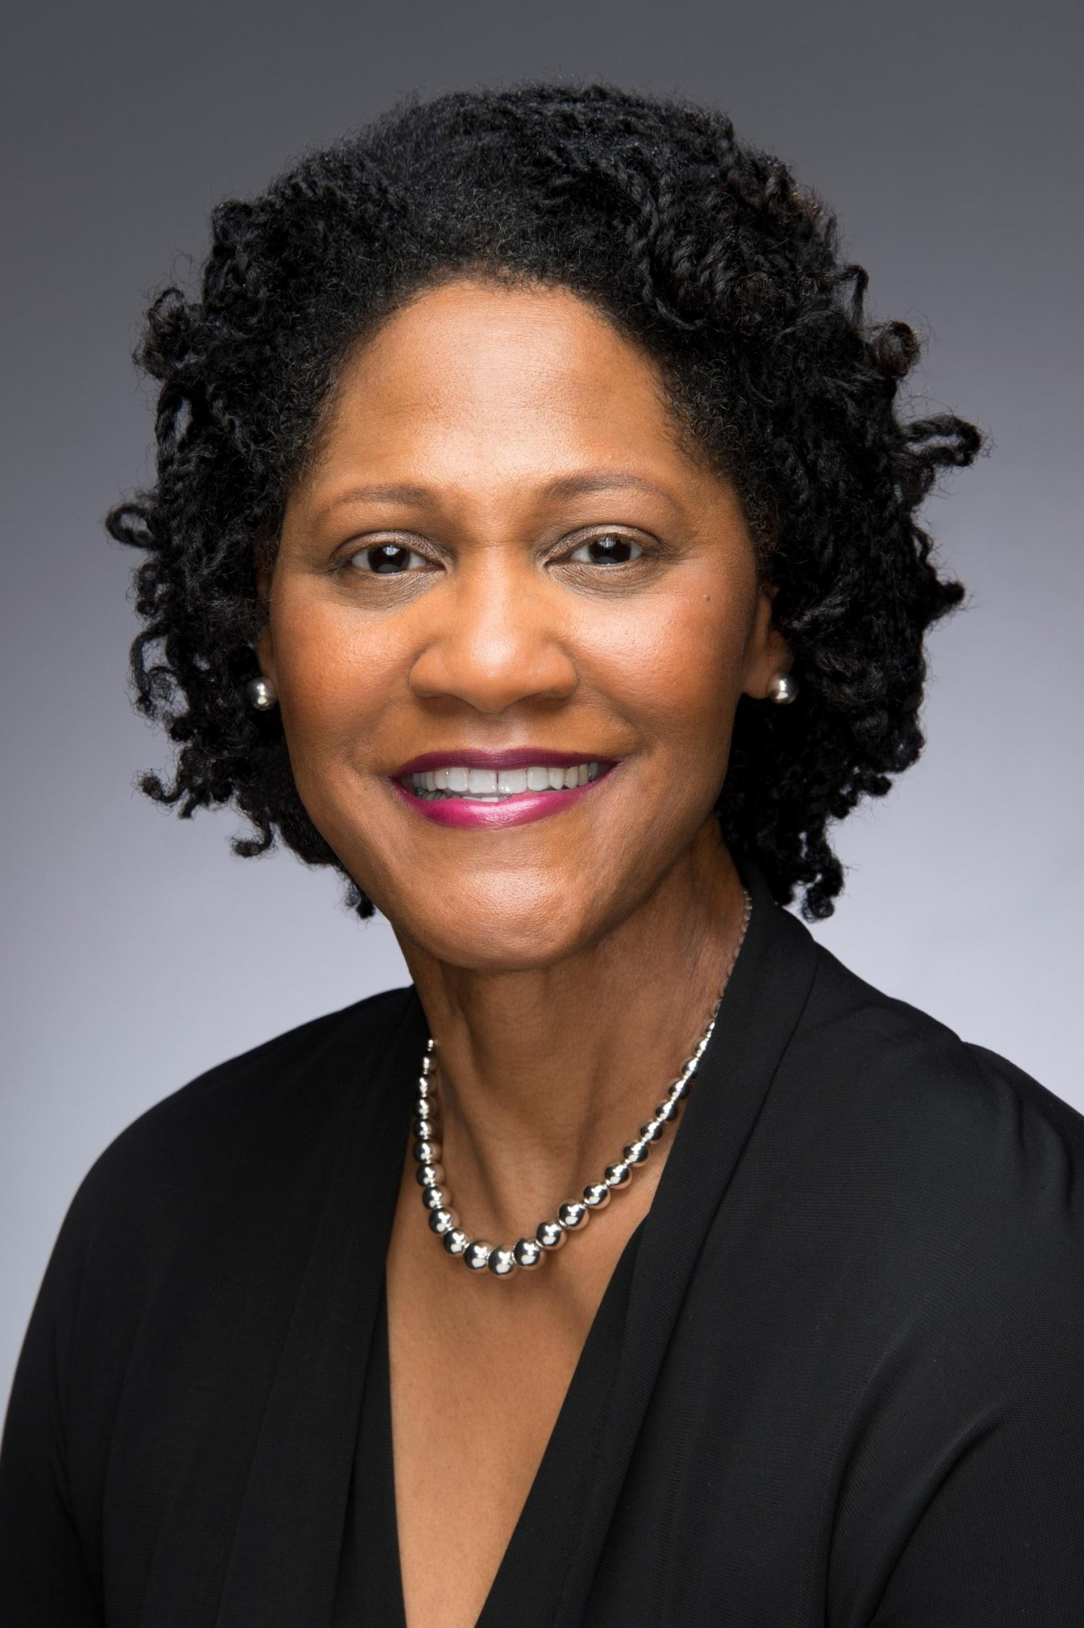
Tanya S. Ellis is a native of Baltimore, Maryland who has resided in Delaware since 2019. She has over 40 years of experience in Quality Assurance and Food Safety holding regional leadership roles with French-owned Sodexo, UK; Coca-Cola Refreshments; GA and McCormick & Company, Inc., MD.
Tanya holds a B.S. Degree in Industrial Engineering from The University of Dayton School of Engineering. She has earned multiple certifications from the International Standards Organization (ISO) including Lead Auditor in Quality Management Systems (ISO 9001), Food Safety Management Systems (ISO 22000) and Environmental Management Systems (ISO 14001).
Tanya also holds several Food Safety certifications including Basic Hazard Analysis Critical Control Point (HACCP), HACCP Plan Development, HACCP Coordinator with Advanced Verification and Validation and Advanced HACCP, International HACCP Alliance; Implementing Safe Quality Food Systems (SQF)- Post Farm Gate and Implementing SQF Systems, Safe Quality Food Institute; ServSafe Food Protection Manager, National Restaurant Association and a Preventive Controls Qualified Individual (PCQI) since 2016, International Food Protection Training Institute.
Tanya was appointed an Examiner for the prestigious Malcolm Baldrige National Quality Award sponsored by the National Institutes for Safety and Health (NISH) and served as an Examiner in 2007 & 2009. She was also appointed to the Board of Examiners for the Maryland Performance Excellence Award sponsored by the Maryland Performance Excellence Foundation, serving 2005-2006 and as a Team Mentor in 2007. In 2008, Tanya was instrumental in leading the team that won the Gold Maryland Performance Excellence Award culminating a 5-year journey using the Seven Baldrige Principles as a roadmap to organizational improvement

She is certified by the American Society for Quality (ASQ) as a Manager of Quality and Organizational Excellence and has been a Senior ASQ Member since 2005. Tanya is a 2006 graduate of the Harford Leadership Academy and previously served as a Board Member for the Harford County Public Library Foundation.

Tanya and her husband have two adult sons. Now that her time is hers, she spends it very wisely doing the things that bring her the most joy. She cherishes her time with family and friends; finds satisfaction in giving back to the community through volunteerism and; enjoys gardening, travel and genealogy. The Scripture that guides her is, “He has shown you, O man, what is good; And what does the Lord require of you But to do justly. To love mercy, And to walk humbly with your God?” Micah 6:8 nkjv

